

FOLLYWELL No.6 Limited

T/AS: **“AMRUQA”**

Vunakanau Estate, P O Box 1593, Rabaul 611,

East New Britain Province, Papua New Guinea

*DEVELOPING GREENER AGRICULTRAL SYSTEMS USING TRADITIONAL & ETHICAL METHODS*

**“AMRUQA” Oils - The Smarter Choice.**

**Proudly Supporting the 2018 APEC Summit - Promoting Agro Tourism & 100% PNG Made Natural Products!**

**“Amruqa”**

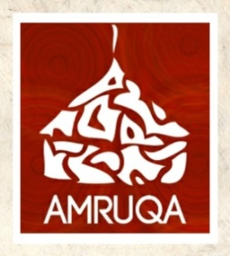

The message is clear; “AMRUQA” Oils are 100% Pure, 100% Natural, 100% PNG Grown, Processed & Made! Totally Transparent, Traceable and 100% PNG Origin ensures true value for our communities. Purchasing Amruqa’s natural products offers a rare opportunity to participate in supporting a traditional way of life, where for many generations the harmonious co-existence with nature has been cherished and nurtured.

“Amruqa Gift Bag” Made by Kalapua #EastNewBritain

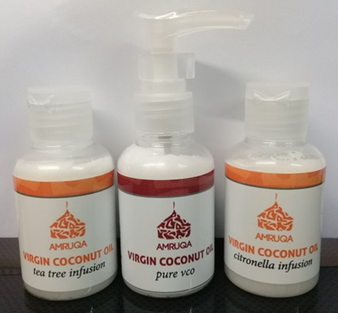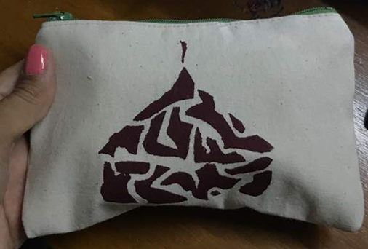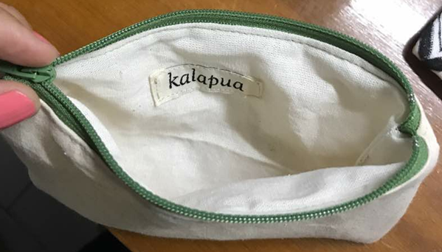

50ml Pure VCO + Tea Tree & Citronella Infusions

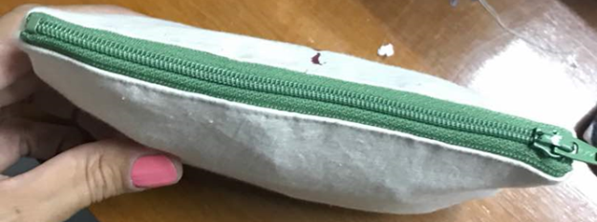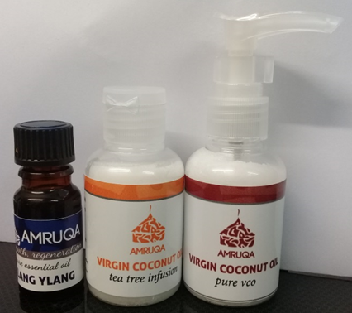

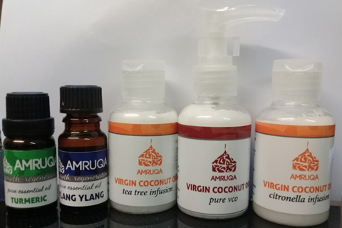

50ml Pure VCO + Tea Tree Infusions & 10ml Essential Oil

**A Selection of AMRUQA Products!**

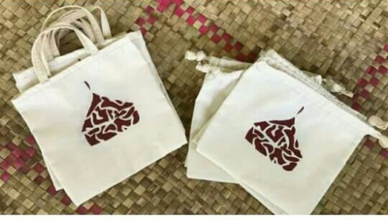

100ml Spray Bottles Pure VCO + Tea Tree, Lemongrass & Citronella Infusions

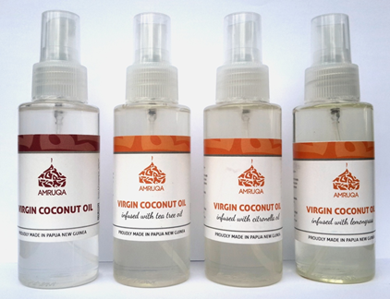

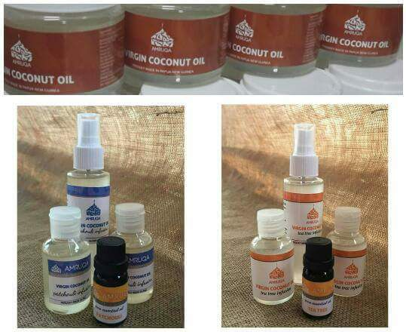

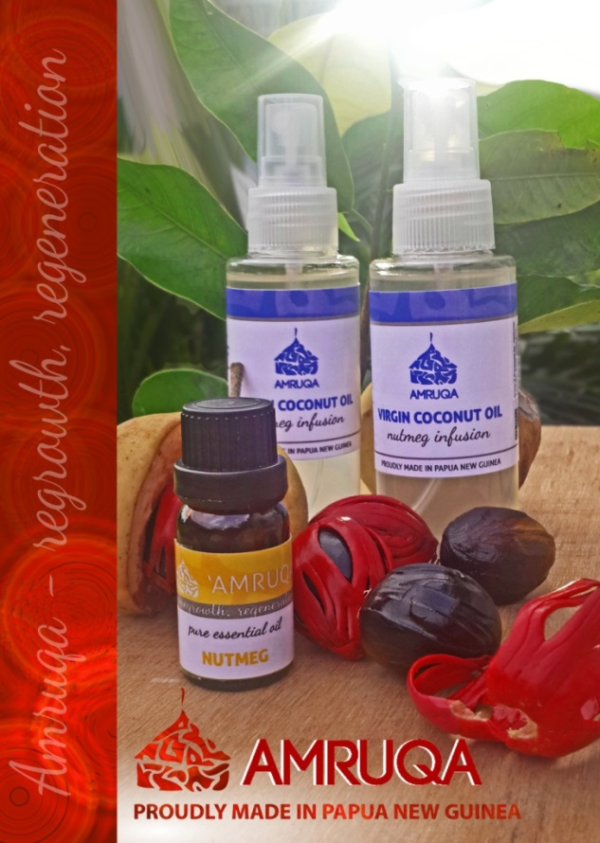

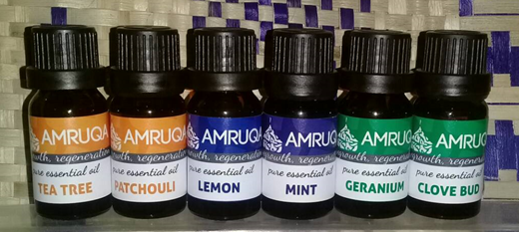

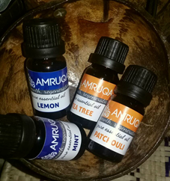

Range of 10ml Essential Oils

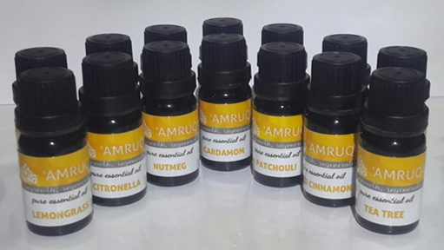

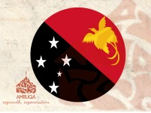Theresa Arek

Managing Director

Follywell No.6 Limited trading as **AMRUQA**

E: [tarek_png@live.com](mailto:tarek_png@live.com)

MB: +675 70379432