100% PURE ESSENTIAL OILS; 100% SINGLE ORIGIN – PAPUA NEW GUINEA
AMRUQA Essential Oils are grown traditionally, the natural way, giving you an organic freshness that holds all the natural goodness and wellbeing that nature intended.

Amruqa Oil &  Botanical Name |  | Profile of the Oil | Key Uses and Actions | Raw Product!
1 | Black Pepper  Piper nigrum | Its fresh, warm, spicy, dry-woody aroma is colourless or pale green in colour. | Energising & warming. Powerful circulatory stimulant which helps to ease muscular aches and pains. | 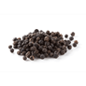  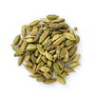
2 | Cardamom  Elettaria cardamomum | Has a sweet-spicy, aromatic smell with a woody, almost floral, undertone to it! | Relaxing, warming, restorative.  Good Antiseptic & Stimulant properties.
3 | Citronella (Java Type)  Cymbopogon winterianus | A pale yellow with a light, fresh lemon scent and geranium-like notes. Very soft and round.! | Antiseptic & Insect Repellent properties make this oil a perfect insect repellent. It is best used in a spray, or diffuser.  Add a few drops to the mopping water when mopping your home. | 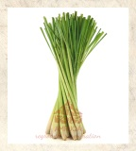
4 | Lavender  Lavandula angustifolia  [Grown & Processed in the UK] | This colourless or pale yellow oil has a very familiar fresh floral slightly harsh and sweet aroma! | Calming, relaxing and restoring... Popular for it’s calming, sedative properties, lavender oil is used in everything from bath salts to candles and skincare products. | 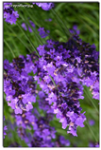
5 | Lemon  Citrus limonum | A clear oil with a fresh citrus smell, reminiscent of its ripe peel! | A circulatory stimulant. Helps with cleansing, uplifting, reviving and stimulating the mind and body.
6 | Lemongrass Oil  Cymbopogon citratus | With a strong middle note it blends well with citrus oils, as well as lavender, peppermint, sandalwood, vetiver and ylang ylang. | Refreshing, balancing and cheerful oil is energizing, strengthening and good for cheering you up. | 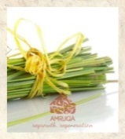
7 | Mint (Japanese Mint)  Menth arvensis | Strong, fresh, sharp, minty scent, full of penetrating top note blends well with all the citrus oils, as well as with lavender, lemongrass, tea tree and ylang ylang.! | Cooling, energizing and minty-fresh. A good mid-day pick-me-up: Put a dab of coconut oil in your hand and mix in 1 drop each peppermint and sweet orange. Rub on the back of your neck and behind your ears. | 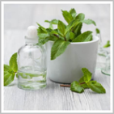
8 | Nutmeg  Myristica fragrans | A pale-yellow mobile liquid with a light, fresh, strong, warm-spicy and aromatic odour. The undertone remains warm and sweet with a slightly woody aroma. | Soothing and comforting properties as well as being emotionally uplifting and balancing. When used for massage, nutmeg essential oil can not only help relieve muscle pain, swelling and inflammation, but also promote circulation. | 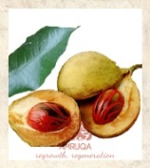
9 | Patchouli  Pogostemon cablin | Earthy, smoky, spicy, and musky | Anti-fungal, anti-inflammatory and healing for cracked or scarred skin.  Very good for skin blemishes and rough patches. Good 'feel good factor'. | 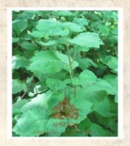
10 | Tea Tree (Australian)  Melaleuca alternifolia | Colourless or pale yellow this oil has a strong, spicy, fresh aroma to it. | Anti-bacterial, anti-viral and anti-fungal Essential oil. It helps to prevent infection and can also control dandruff. | 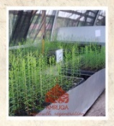
11 | Turmeric  Curcuma longa | A yellowy-orange oil with a faint blue fluorescence. Fresh, spicy-woody aromatic scent with a slightly pungent and bitter flavour. | Associated with a number of health benefits for the skin and for the body.  Reduces inflammation, optimizes digestion, stimulates circulation, & strengthens the immune system.
12 | Vetiver  Vetiveria zizaniodes | An amber dark brown colour with a sweet heavy aroma of woody earthy undertones and lemony top notes! | Deeply relaxing, calms an overactive mind. Grounding and emotionally strengthening | 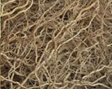
13 | Wild Cinnamon  Cinnamomum cassia | A Yellow or brownish-yellow oil with a harsh, warm and spicy, slightly sweet scent! | Energising, warming, spicy, aphrodisiac. Stimulates, energizes and warms - a great way to spice up your life!
14 | Ylang Ylang  Cananga odorata | A pale yellow viscous oil with a powerful yet intensely sweet and exotic floral scent with a balsamic undertone! | Sensual and euphoric aroma with natural anti-depressant, can balance the skin's sebaceous activity. It also promotes healthy hair. | 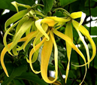

Origin: Papua New Guinea
Production Process: Steam Distillation of Dry Leaf
Safety: Harmful if swallowed. Avoid contact with eyes.
Storage: Store in cool, dry place in tightly sealed containers, protected from heat and light.
Shelf Life: 36 month(s) or longer if stored properly and not opened.

The shelf life of these products is influenced by many conditions of which temperature, exposure to light / air and general good storage are the major factors. Material stored in adverse conditions may deteriorate much faster.
Expiry date must be considered as subjective; the expiry date given here is based on the best of our knowledge and experience of the material when stored under recommended conditions in original unopened containers.
Due to the natural ingredients contained in many of our products, there may be a slight batch to batch variation in the colour, odour or consistency. However, we ensure that this does not affect the quality and efficiency of the products in any way.
These materials do not contain any impurities/heavy metals or preservatives

CAUTION:
• Pregnant women should not use essential oils without consulting their GP first.
• It is not recommended to use essential oils directly on your skin. Remember everyone reacts differently, what is good for one person may not be good for another.
• General rule of thumb if you are diluting your essential oils for application to your skin – adults 3%-5% and children 2%.
• Keep your essential oils out of children’s reach.
• Thoroughly rinse with water if there is any irritation.

